Task 1:
Discrete-event simulation (DES) lets us model patient flow through Fast Track and Main ED, staff and bed resources, labs, and ward-transfer (boarding). It also allows modeling of arrival processes (hourly rates / NHPP if needed), service-time and lab distributions, and admission probabilities from historical timestamps. It can also model branching (Fast vs Main), probabilistic paths (lab required, admitted vs discharged), and the stateful holding of admitted patients in ED beds while waiting for ward transfer. Lastly, the model can be validated by comparing simulated KPIs captured in the real world (mean/median LOS, wait times, throughput, boarding prevalence).
Primary uses:
- Baseline quantification: estimate avg/percentile wait, LOS, bed occupancy, resource utilizations, boarding times, and daily throughput.
- Stress testing future demand: increase arrival intensities (+1 arrivals/hour) and check when KPIs breach tolerances.
- What-if experiments: change staff counts per shift, add beds, shorten transfer delays, or expand Fast Track and measure KPI deltas and confidence intervals.
- Prioritization by ROI: compute benefit per resource (e.g., minutes reduced per additional doctor FTE) to recommend cost-effective changes.
- Operational guidance & monitoring: generate daily/weekly scenario runs to support tactical scheduling decisions.
Deliverables: parameterized SimPy model, CSV outputs and plots for KPI comparison, and a separate PowerPoint that presents findings and prioritized recommendations. It also uses multiple replications to compute 95% CIs and report replication count on slides.

Task 2:

- Components of the system

System | Banking
Entities | Patients
Resources | Fast_doctor, Fast_nurse, Main_doctor, Main_nurse, ED beds
Attributes | Fast doctor service, fast lab test, main doctor service, main lab test, transfer out of ED
Activity | Visit doctor, take lab test, get ED bed
Events | Arrival, Departure
State Variables | Number of patients waiting
Fig 2.1 Components of Emergency Department

- Input data needed to model the system
  - Arrival rate
  - Probability of patients sent to Fast Track
  - Probability of patients in Fast Track and Main ED that needs lab tests
  - Probability of admission of patients in Main ED
  - Number of doctors and nurses in Main ED
  - Number of ED beds
  - Length of service time for patients in Fast Track and Main ED
  - Length of lab test for patients in Fast Track and Main ED
  - Time delay before patients can be transferred out of ED
- simulation outputs collected
  - ed_summary.csv: Summarises the most important statistics within the replication runs and provides a high level overview
  - wait_samples.csv: Shows how long each patient takes from arrival to first service
  - los_samples.csv: Shows how long each patients takes from leaving the ED service to arrival
  - queue_samples.csv: Shows queue status for bed, main doctors, main nurses, fast track doctor, fast track nurses and number of beds in use currently
- assumptions made
  - Technicians and number of laboratories are not modeled in this study
  - Spatial constraints (eg. max queue length) are not modeled in the study
  - Other services (eg. insurance claims, payments, visitation, medicine collections) are not modeled in this study
  - A doctor and a nurse is needed to service patient
  - A single nurse is required to conduct the lab test
  - No doctor and nurse is needed to serve patient on ED beds
  - Patient, both in the main track and fast track, have to be serviced by the doctor again after completing the lab test to review the results
  - Doctor and nurse is able to serve the next patient while the previous patient is going through the lab test
  - Patient visiting the doctor after lab test joins the main/ fast queue again
  - Patient arrival rate follows a poisson distribution
  - Patient service time by doctor and nurse follows a normal distribution
  - Patient lab tests and ED bed transfer delay follows an exponential distribution

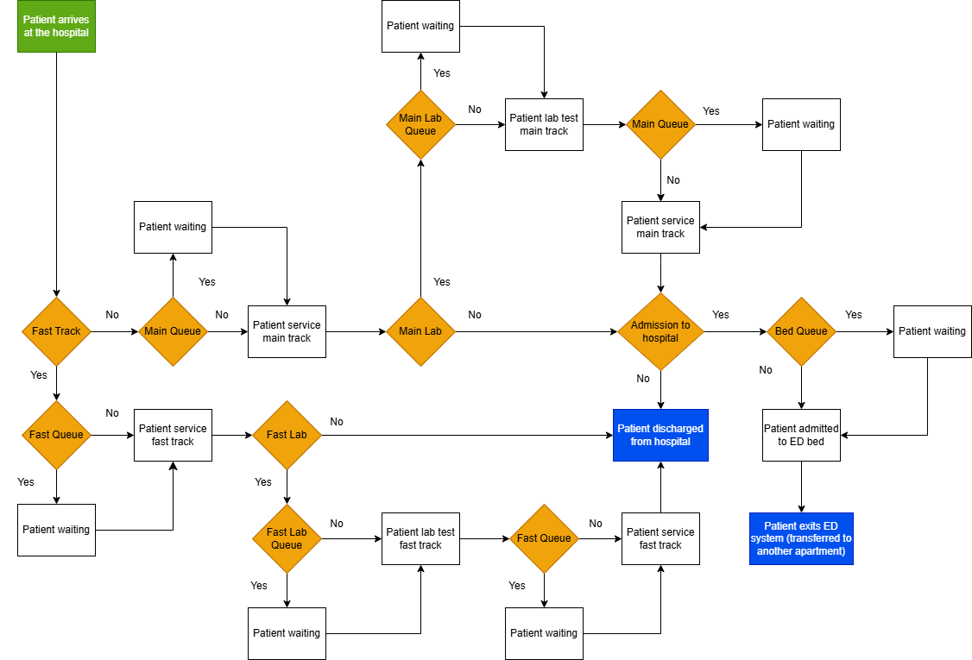
Fig 2.2 Process flow chart of Emergency Department

